**AI Lab - 11**

**Implementation of learning algorithms for an application**

***Submitted By***

***Name: VINOTH S***

***Reg No: RA1911030010103***

***Date: 05-04-2022***

***GitHub Link: https://github.com/vk1308***

**Aim:**

1. Implementation of Linear Regression algorithm to predict students score using the given dataset.
2. Implementation of Support Vector Classiﬁcation algorithm to classify the cases of breast cancer

using the given dataset.

1. Implementation of K-means clustering algorithm to group the customers based on their

demographic detail using the given dataset.

**Code:**

import pandas as pd

import numpy as np

import matplotlib.pyplot as plt

from sklearn.model_selection import train_test_split from sklearn.linear_model import LinearRegression from sklearn import metrics

%matplotlib inline dataset=pd.read_csv('student_scores.csv') dataset.head()

dataset.shape dataset.describe()

dataset.plot(x='Hours', y='scores', style='o') plt.title('Hours vs Percentage')

plt.xlabel('Hours Studied')

plt.ylabel('Percentage Score')

plt.show()

X = dataset.iloc[:, :-1].values

y = dataset.iloc[:, 1].values

X_train, X_test, y_train, y_test = train_test_split(X, y,test_size=0.2, random_state=0)

print('X train shape: ', X_train.shape) print('Y train shape: ', y_train.shape) print('X test shape: ', X_test.shape)

print('Y test shape: ', y_test.shape)

regressor = LinearRegression()

regressor.fit(X_train, y_train)

print(regressor.intercept_) print(regressor.coef_)

y_pred = regressor.predict(X_test)

df = pd.DataFrame({'Actual': y_test, 'Predicted': y_pred}) print(df)

print('Mean Absolute Error:',

metrics.mean_absolute_error (y_test, y_pred))

print('Mean Squared Error:',

metrics.mean_squared_error (y_test, y_pred))

print('Root Mean Squared Error:',

np.sqrt(metrics.mean_squared_error (y_test, y_pred)))

import pandas as pd

import numpy as np

import matplotlib.pyplot as plt

from sklearn.model_selection import train_test_split

from sklearn.svm import SVC

from sklearn.metrics import confusion_matrix

dataset = pd.read_csv('diabetes.csv')

print(dataset.head())

dataset = pd.read_csv('diabetes.csv') print(dataset.head())

dataset.head()

def diagnosis(x):

if x=='M' :

return 1

if x=='B' :

return 0

dataset['DiabetesPedigreeFunction'] = dataset['DiabetesPedigreeFunction'].apply(diagnosis) print(dataset)

svc_classifier=SVC(kernel='rbf') svc_classifier

Y = dataset['DiabetesPedigreeFunction']

X = dataset.drop(columns=['DiabetesPedigreeFunction']) X_train, X_test, Y_train, Y_test = train_test_split(X, Y,

test_size=0.2, random_state=9)

X_train, X_test, Y_train, Y_test = train_test_split(X, Y, test_size=0.2, random_state=9)

print('X train shape: ', X_train.shape) print('Y train shape: ', Y_train.shape) print('X test shape: ', X_test.shape)   
print('Y test shape: ', Y_test.shape) svc_classifier= SVC(kernel='poly')

c)

import pandas as pd

import numpy as np

import matplotlib.pyplot as plt

from sklearn.model_selection import train_test_split

from sklearn.cluster import KMeans

from sklearn.metrics import silhouette_score

%matplotlib inline data=pd.read_csv('mall_customers.csv') print(data.head())

inVsout=data.iloc[:,[3,4]]

inVsout plt.scatter(inVsout.iloc[:0],inVsout.iloc[:,1]) kmeans=KMeans(n_clusters=5)

kmeans.fit(inVsout) plt.scatter(inVsout.iloc[:0],inVsout.iloc[:,1],c=kmeans.labels_,cmap='rain bow')

plt.show()

# OUTPUT:

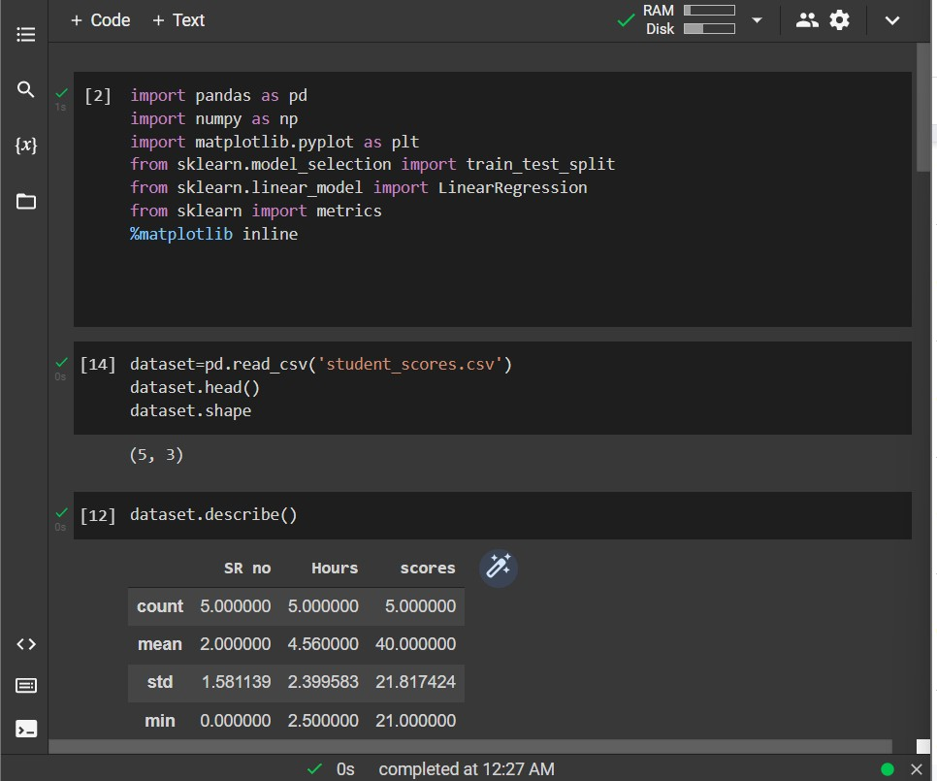

a)

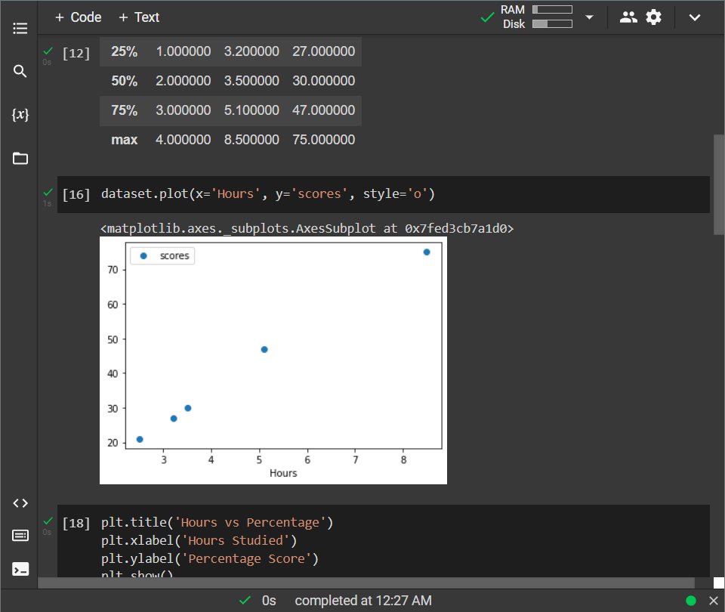

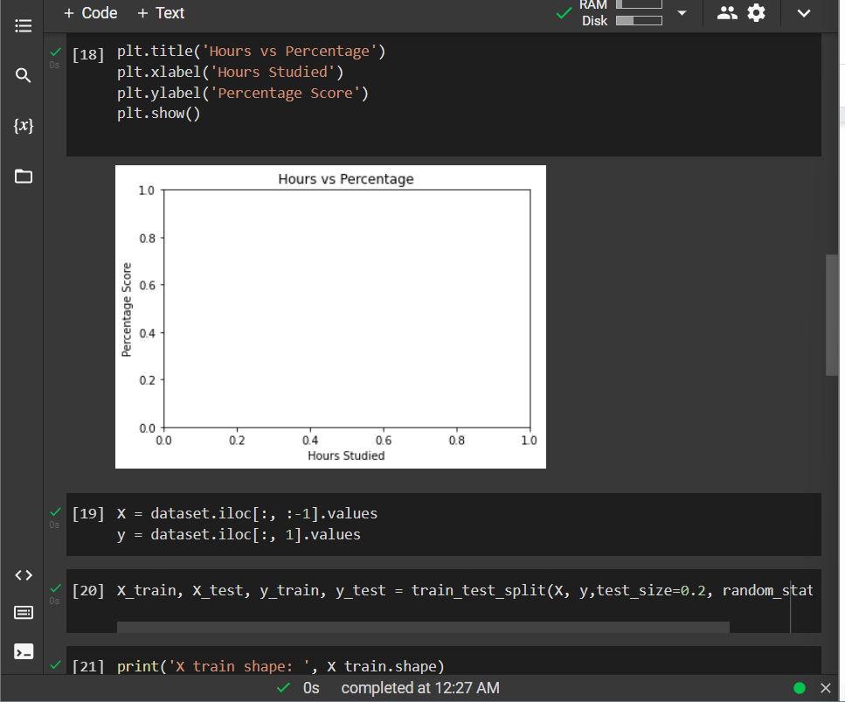

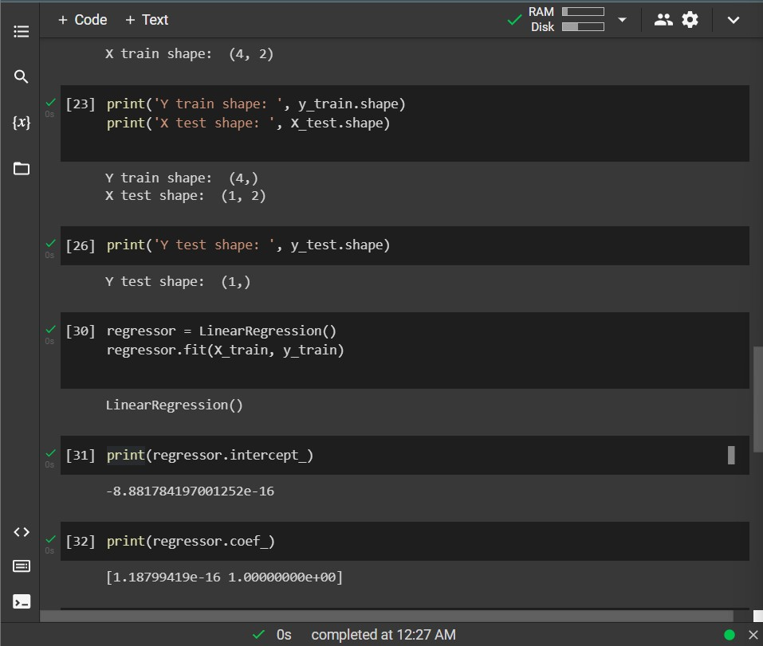

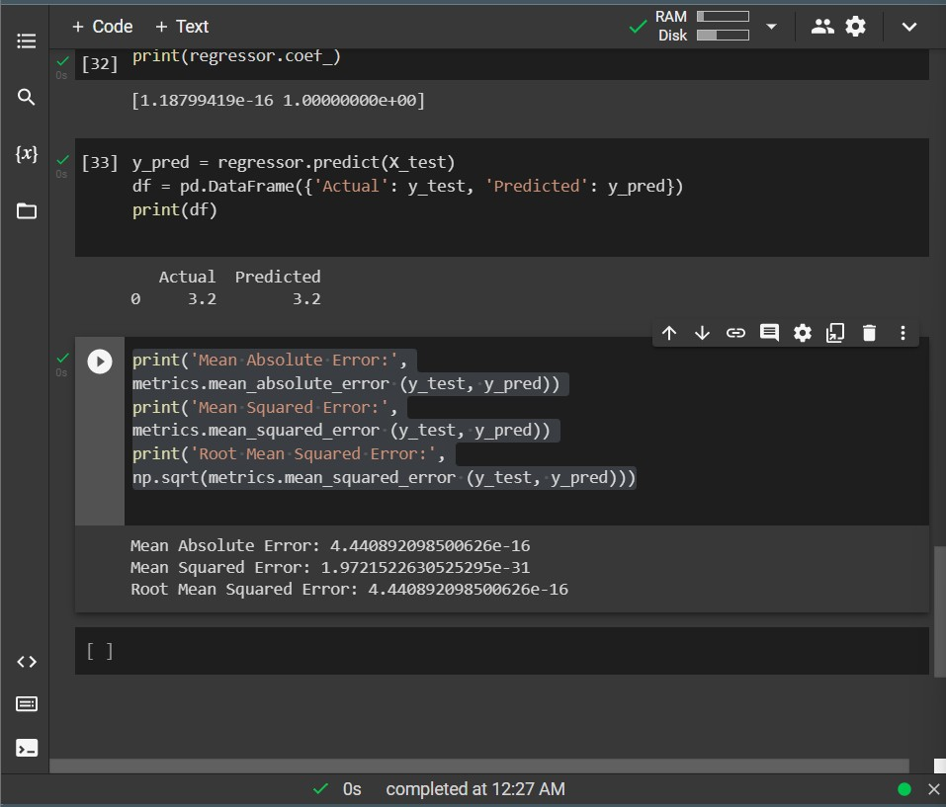

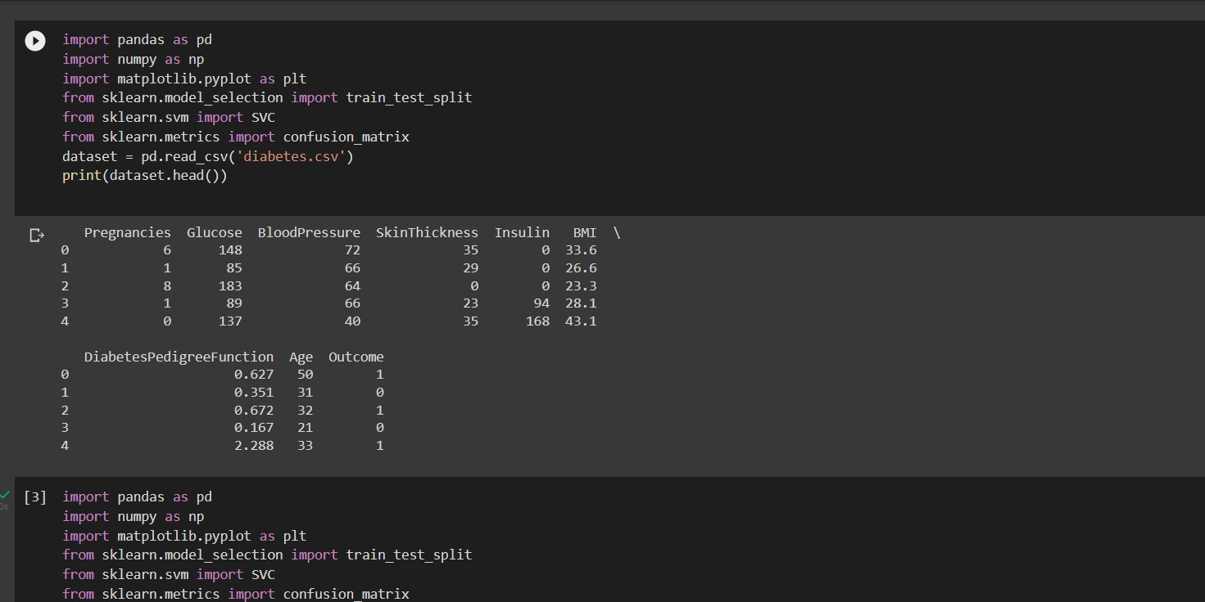

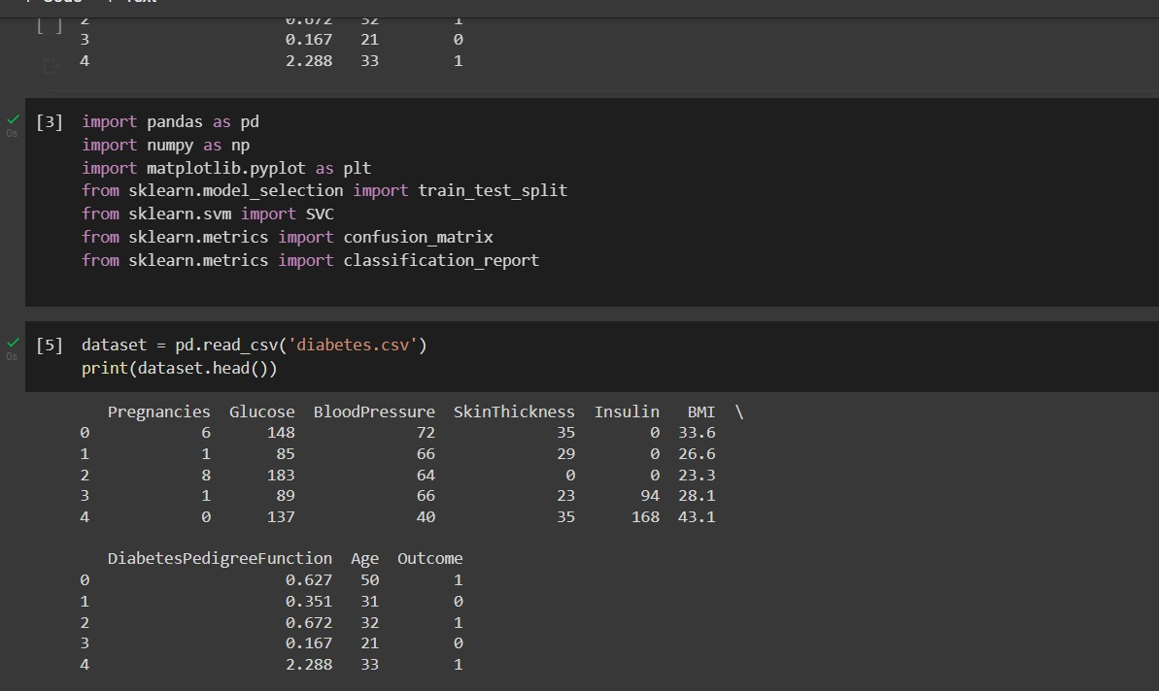b)

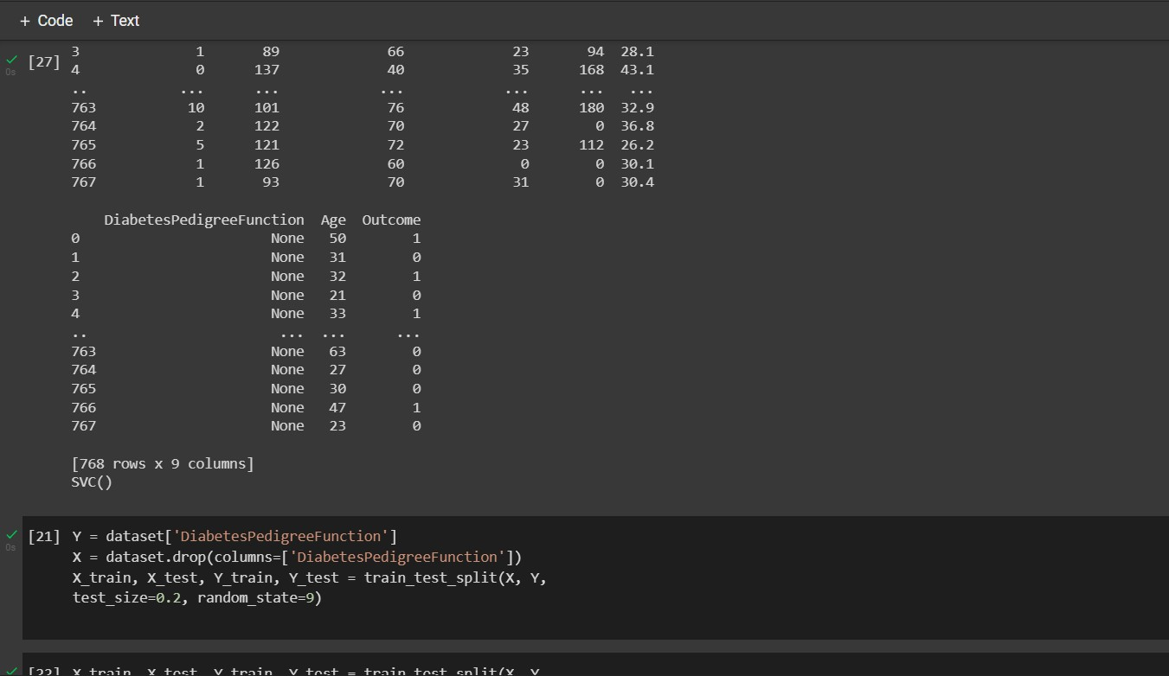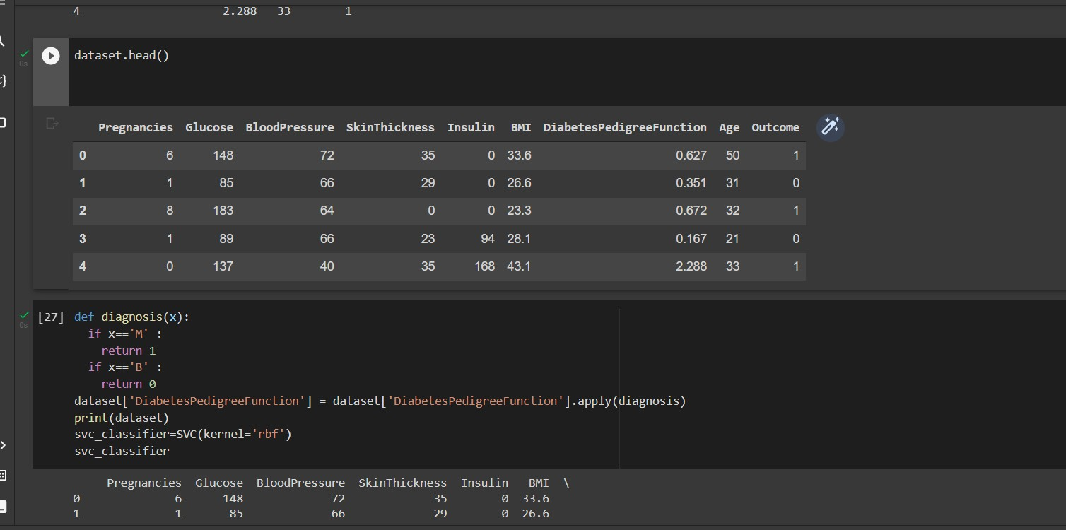

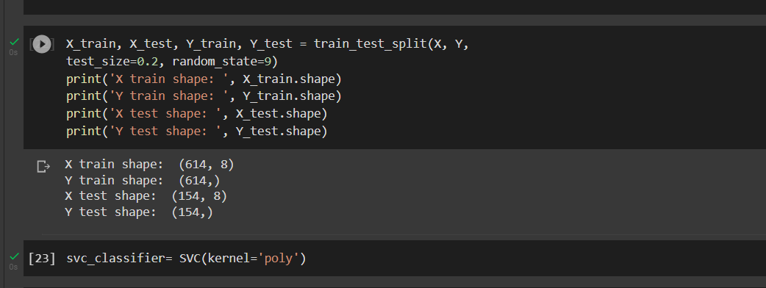

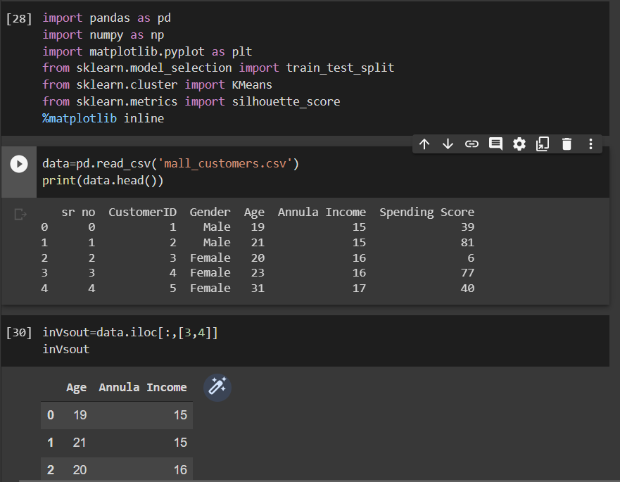c)

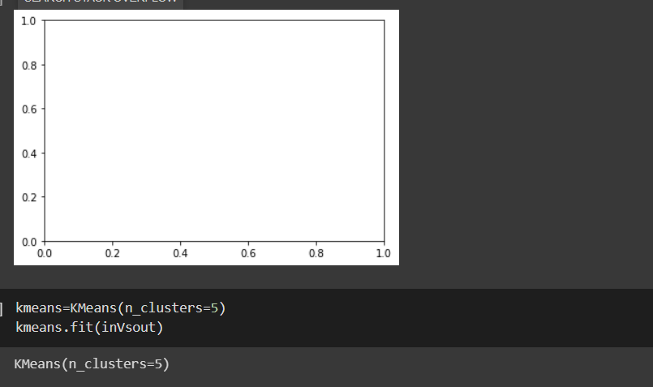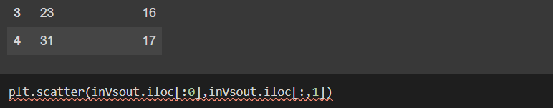



# Result:

Hence we have successfully fulﬁlled implementation of learning algorithms for an example.